Use-Case Realization Report (Analysis)
Add Survey

Issue 1.0
Revision History
Date | Issue | Description | Author
01/Aug/09 | 1.0 | First Issue | Thomas Yap

Table of Contents
1. Brief Description 4
2. Flow of Events 4
2.1 Standard Flow 4
2.1.1 Add Survey 4
2.2 Exception 4
3. Interaction Diagrams 5
3.1 Collaboration Diagram for Add Survey 5
4. Participating Objects 5
5. Class Diagrams 6
5.1 Class Diagram for Add Survey 6
6. Derived Requirements 6

Use-Case Realization Report
Add Survey

Brief Description
This use case enables the controller to add new survey to Survey Pool. It involves displaying the menu and form for keying in the survey details.

Flow of Events
The standard flow of events for this use case and any exceptions are described in the following subsections. The events are described in terms of Actors and Analysis Objects.

Standard Flow
This use case covers the Survey Maintenance - Add Survey. The standard flow of these events are described below.

Add Survey
The running of the application is shown in section 3.1. The flow of event is as follow:

- When the application start, the first operation to be performed is the startup operation of the main controller. This operation will create all the control objects and the entity objects necessary for operation Add Survey:
  - The control object created is: Survey Controller
  - The entity objects create are: Survey and Transaction Record

- The main controller will start the main function menu:
  - To start Add MCQ, operation FormAddSurvey is activated by SurveyController to display a Survey form.
  - Portal Admin then input the data.
  - Operation validate will validate the format of the entries.
  - Then SurveyController will check for duplication.
  - If no issue found, Survey Controller will send a confirmation request to FormAddSurvey Interface.
  - Upon confirmation, the data will then be written to file using operation create to entity object Survey.
  - In addition, a transaction log will be created by operation create and store in entity TransactionRecord.
  - The adding request can be cancelled and no data will be stored.
  - A transaction record will still be created for traceability.
  - A confirmation message will be displayed by FormAddSurvey interface.

- Step 2 will be repeated until all new entries are added to the system. Then controller will terminate the application by issuing operation close.

Exception
None.

Interaction Diagrams

Collaboration Diagram for Add Survey
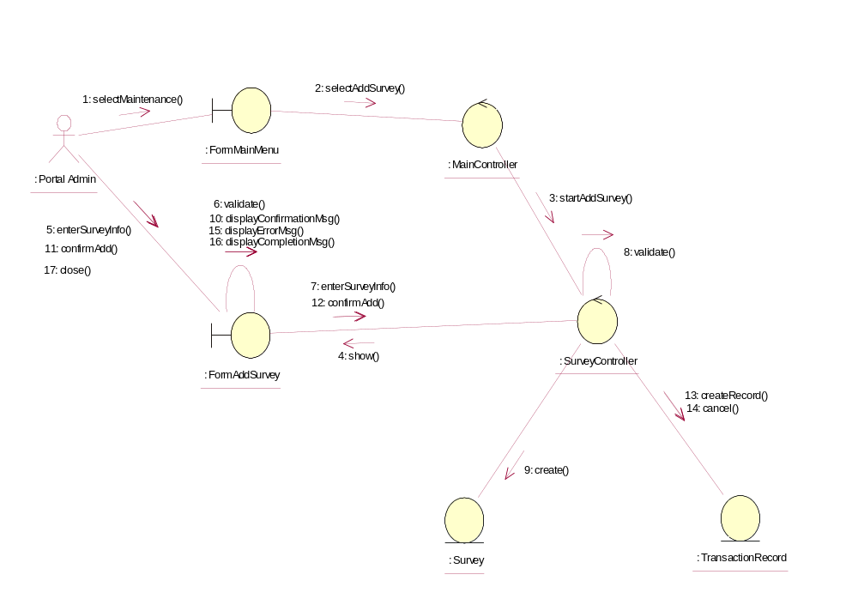

Participating Objects
: FormAddSurvey
This object is the interface for keying Surveys details.

: FormMainMenu
This is the main menu at the beginning of the application from where it can access the Survey Maintenance - Add Survey operation.

: MainController
This is the main controller that control the whole system.

: Portal Admin
This is the only actor that authorized to perform operation Survey Maintenance - Add Survey.

: Survey
This entity stores all the exam or exercise Surveys.

: SurveyController
This is the controller for Survey Maintenance. It creates and activates FormAddSurvey interface and Survey entity object.

: TransactionRecord
This is the entity object that created for transaction log and audit trail.

Class Diagrams

Class Diagram for Add Survey
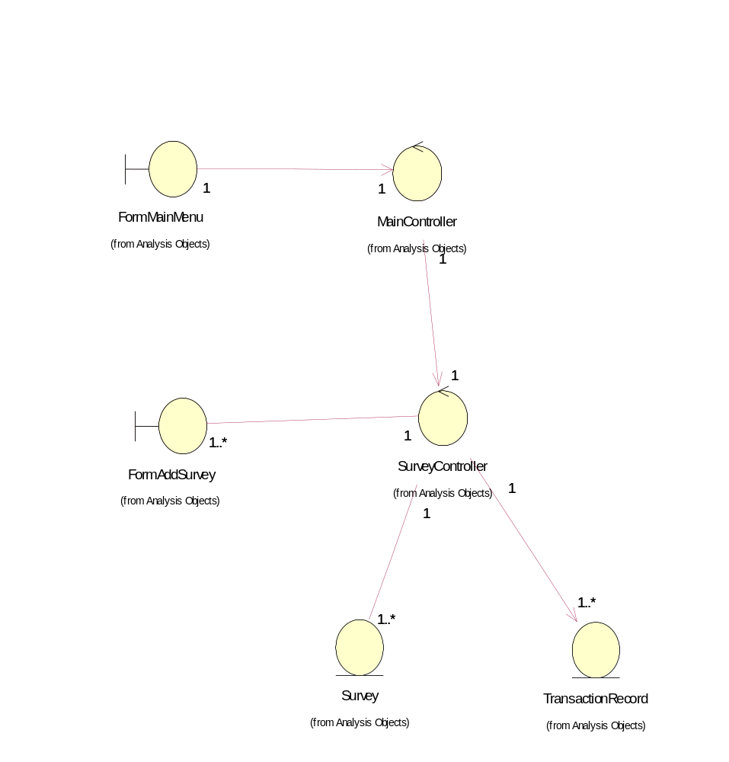

Derived Requirements
The FormMainMenu and FormAddSurvey Interface should have the format specified in User Requirements Specification for Content Management Portal.

